 PROJECT REPORT ON

“Pesonal Porfolio Techical Documentation”

A Project Report Submitted in Partial fulfillments of Requirements for the Award of the Degree of

# BACHELOR OF TECHNOLOGY

IN

# ELECTRONICS AND COMMUNICATION ENGINEERING

**Submitted To**



# Submitted By

**Team Id:LTVIP2023TMIDO5288**

**Team Leader:V.Reddeppa(20HU1A0451)**

**Team Members**

**V.Venkata Sudhir(20HU1A0454)**

**V.Nani Avinash (20HU1A0455)**

**Y.Nagarjuna (20HU1A0456)**

**B.Purna Srinivas (21HU5A0403)**

PERSONAL TECHNICAL

PORTFOLIO

DOCUMENTATION

## INTRODUCTION:

### 1.1OVERVIEW:

The Personal Technical Portfolio is a static web application designed to showcase an individual's technical skills, projects, achievements, and experience in a visually appealing and organized manner. It aims to highlighttheir expertise, demonstrate their coding abilities, and provide a comprehensive understanding of their technical background to potential employers, clients, or collaborators.

The goal of this application is to create avisually compelling and professional portfolio that impresses visitors and establishes a strong online presence.

## https://lh3.googleusercontent.com/rHhykq7kF_eOOuwuMhbCmN2XbW8TuEFPr_z_U4owOZw3C55ynGD_8mEkPnoa7osA4zv5E-XP2VSGEeapuPWS6zYN169xxyVMq7aBj2o5DThQsVMJ3gjsHiUqIWf4lJlyE9AaGtY3szFhcTOy-24VmgTechnical Architecture

### PURPOSE:

While there are innumerable benefits to launching your online portfolio, a few stand out from the rest. These benefits might be exactly what you’re looking for if you’re in the middle of a job hunt, are coming up on graduation, or are considering a competitive career.

**LITERATURE SURVEY**

## Existing Problems:

In this post, we provide a simple checklist of common portfolio mistakes, and how to fix them, quickly and easily. You might also want to check out

these [excellent design portfolio examples](https://www.creativebloq.com/portfolios/examples-712368) and be sure to display your portfolio on the [best ultrawide monitor](https://www.creativebloq.com/features/best-ultrawide-monitor), too.

## Addressing the wrong audience

When you first launch a portfolio website, your first feedback comes from family, friends and co-workers. So there’s always a natural impulse, conscious or subconscious, to fashion something that these particular people will go ‘wow!’ at.

But that’s not the audience you need to be worrying about. You need to consider what a potential client or employer will be looking for and how they’ll be viewing your portfolio, which will usually be completely different from a friend or colleague. The former, for instance, will probably spend a long time looking at different aspects of your site; the latter will be seeking much more specific information, much faster.Once you start thinking along these lines, what you need to include on your portfolio site and how you organise it becomes a lot clearer.

## Too much work on show

You’re proud of everything you’ve done, and people want to see as much of your work as possible, right? Wrong.

Potential clients and employers don’t wish to spend ages trawling through your back catalogue until they find something they like. They’re more likely to glance at one or two pieces, and make a snap decision. So you need to be ruthless in selecting only your absolute best work and putting it front and centre.

While people are willing to rummage for cheap items at a jumble sale, when you enter a high-end store you see much smaller collection of carefully curated items. Apply the same logic to your portfolio site and you won’t go far wrong.

## 03.Lack of context

There’s no point in just posting visuals by themselves, with no explanation of the context for which they were created.

Let’s return to our potential client or employer. Ask yourself: what will they want to know? At the very least, probably a combination of the following: When was the work created?

How was it created? Is this entirely your work, or a collaboration (in which case, who else was involved, and what part did you play?). What was the brief? Was the client happy?

What was the timeline? What elements of the project are not shown here?

That’s the bare minimum you need, but it doesn’t hurt to provide more. Remember in

maths at school when you were told not just to give the answer, but “show your working”? That’s a good rule to apply to portfolio sites too.

So if it’s possible (check with the client first!), consider writing a full case study, including notes on the design process; early sketches; rejected concepts and designs, and so forth.

## 04.Too little work on show

While including too many examples of your work is the most common portfolio mistake, designers at the beginning of their careers can often make the opposite mistake: showing too little.

Put simply, if the Work section of your website is too sparsely populated, it doesn’t give a great impression. Not had enough commissioned work? Then there’s nothing wrong with posting student projects, as long as you clearly explain what the brief was and how you fulfilled it.

Don’t have enough student projects? Then just do some designs of your own, label them as [‘personal projects](https://www.creativebloq.com/features/why-you-should-make-time-for-creative-side-projects)’, and again, explain the thinking behind them.

Real-world commercial work is always preferable of course, but demonstrating that you can deliver something to a brief, even an imaginary one, is much better than leaving a blank space.

## 05.Vague and incomplete personal informat

As well as providing information about the work itself, you also need to provide a clear explanation of who you are and what you do, normally in an ‘About Me’ section.

There’s a current trend to just add a ‘snappy’ or ‘witty’ tagline under the designer’s name, something like “Designer of things for money”. You might be able to get away with this if you’re extremely well known, but if not, this is a massive turn-off for clients or employers.

Another common portfolio crime is making your contact details hard to find, or even non- existent. Again, if you’re a world-famous designer then refusing to give an email and saying

“The best place to find me is on Twitter" might be acceptable. For the rest of us, it’s not, so just provide a damn email address.

## 06.A lack of purpose

Many portfolio websites avoid making the previous obvious mistakes but are still failures because it’s just not clear what they’re trying to achieve.

Often that’s because the designer doesn’t know themselves, beyond a general ‘well, you’ve got to have a website, haven’t you?’

But if you don’t think about what you want your website to achieve, how will you know if you’ve achieved it? So before you start, sit down to have a long, hard think about what your main goals are.

For instance, if you’re looking to get a job, have you made that clear? People are not telepathic so if you don’t say, people will assume you’re happy to remain a freelancer.

Alternatively, maybe you already have enough freelance work, but wouldn’t mind getting some better paid commissions? In which case, why not make your preferred rates clear, and avoid long email conversations with time-wasters who just want to lowball you?

Or perhaps you don’t want more work right now, but just want to steadily build up your name and reputation. In which case, you’ll want to think about including testimonials, press reviews and other ‘social proof’ to bolster your standing.

# 07.It doesn’t work on mobile

The best way for someone to view your portfolio is always going to be on a big, beautiful widescreen monitor. But you can’t guarantee that’s what will happen.

These days, it’s increasingly likely that potential clients and employers will be viewing your portfolio site on mobile devices. So you need to make sure it’s not going to look awful on a small screen.

Most importantly, can you view the images properly, or do they reduce down to tiny, formless thumbnails? If the answer to that question is yes, then your site is not fit for purpose.

# 08.It’s out of date

Once you’re happy with your portfolio site, don’t just ‘set it and forget it’.

Potential clients and employers may well look at your site a number of times over the course of a year. If nothing new is added, they may assume you’ve had no work. So think about how you can refresh the site on a regular basis. Could you add new work examples, refresh the design or maybe even add a blog?

Also, sign on with Google Analytics to find out how many people are visiting the site, and which bits they’re most interested in. Don’t jump to unwarranted conclusions, but do use this information to improve the site and its content, bit by bit, over time.

### Proposed Solutions:

**Here are some basic tips to help you make your portfolio more effective:**

* The quality of the work you share is more important than the quantity. ...
* Refrain from enclosing any original work. ...
* Attach digital samples or links to content wherever required. ...
* Keep the design and layout of your portfolio simple. ...
* Share information in an organised and systematic manner.

**THEORITICAL ANALYSIS:**

### Block Diagram:

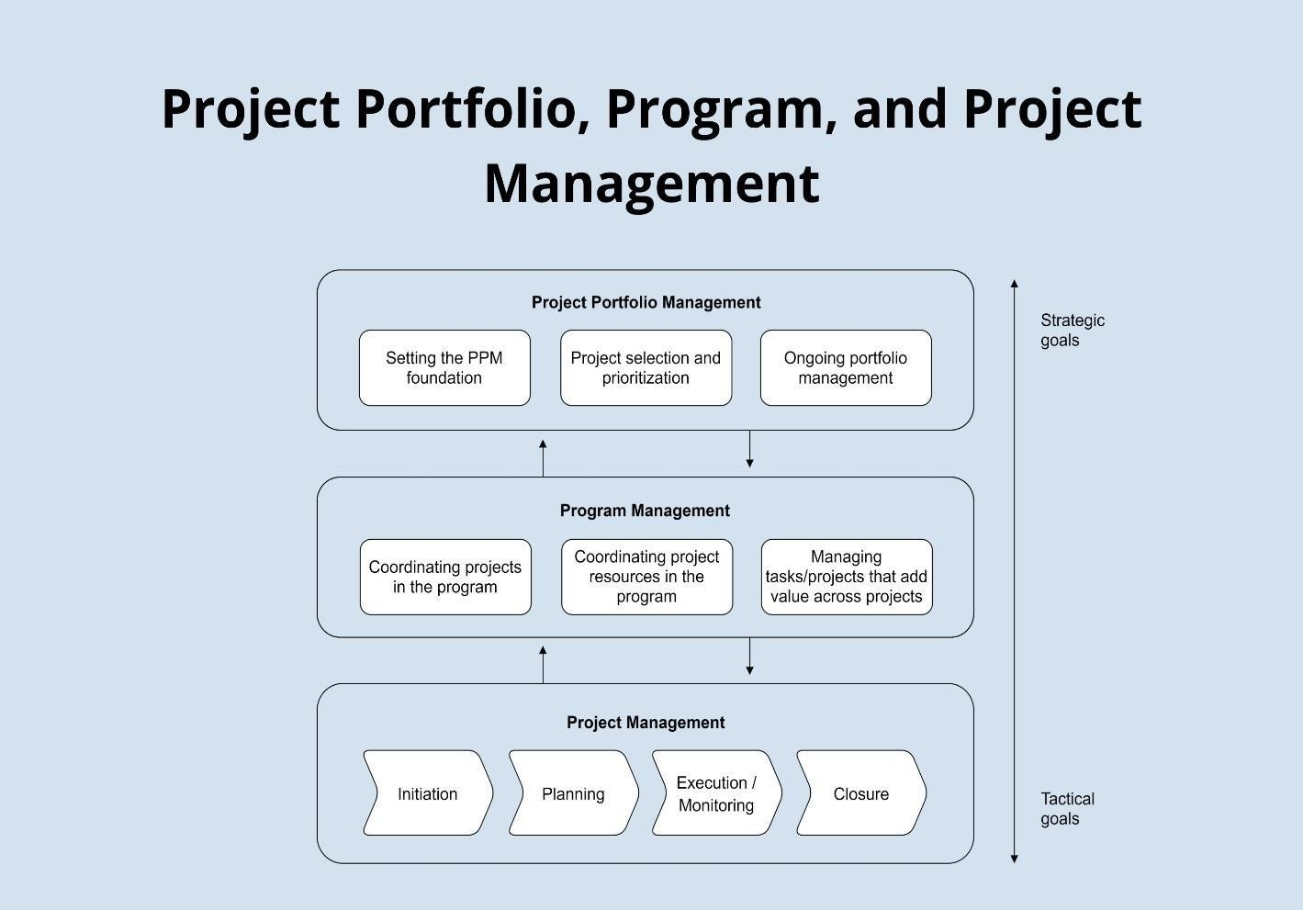

* 1. **Hardware / Software designing:**

To design a personal portfolio app, you can follow these steps:

* + 1. Choose a template or type in your app name.
    2. Choose the appropriate app category, color theme, and test device.
    3. Customize the template or drag & drop the right features to add the relevant features to your app without learning to code.
    4. Add content and make monetization settings.



5. [Launch your portfolio app .](https://www.appypie.com/portfolio-app-builder)

If you want to create an android app for your portfolio, you can use Andromo’s Portfolio App Maker. The first step is to go to the Easy Start section and select a pre-set template for the mobile application. The creator can later change the components of the template.

Customize it, add Content, make monetization settings .

If you want to learn more about how to create a digital portfolio, you can check out Canva’s guide on how to create a digital portfolio. Start designing your portfolio by looking at all the work you’ve done, then choose your favorite pieces and the work you’ve gotten the most positive feedback for. Next, diversify your options and choose examples that show a full range of your abilities. This way, the reader is able to see your adaptability and creativity.

**RESULT**

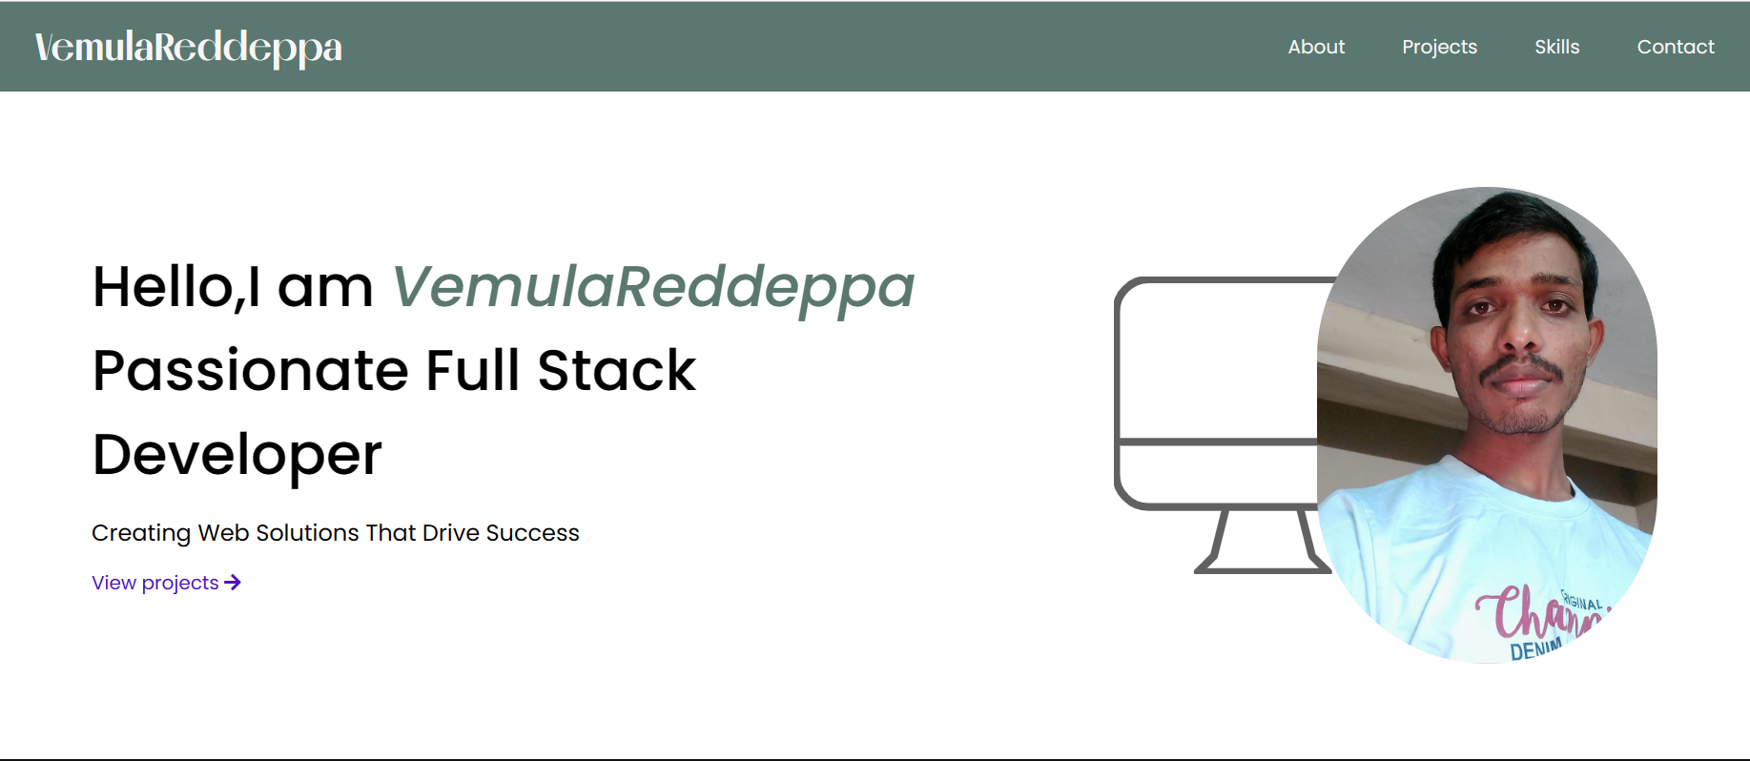

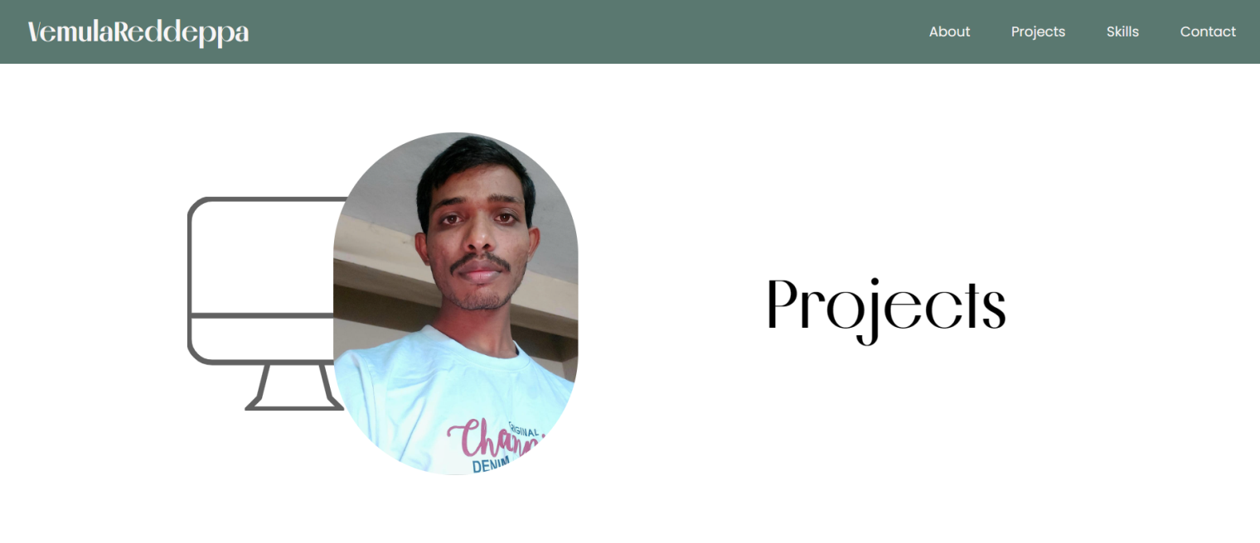

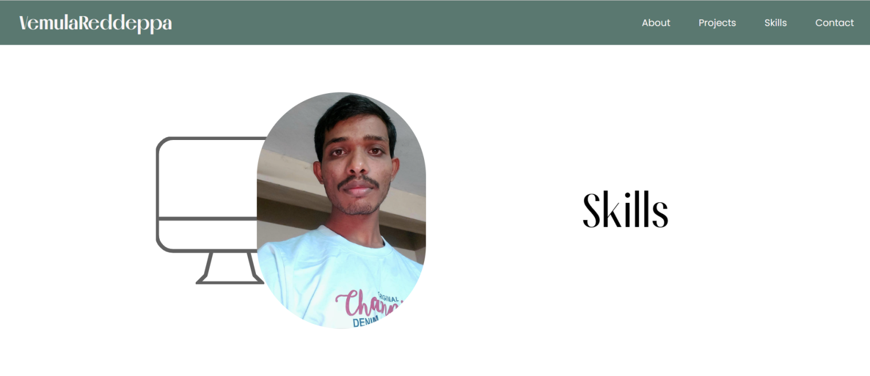

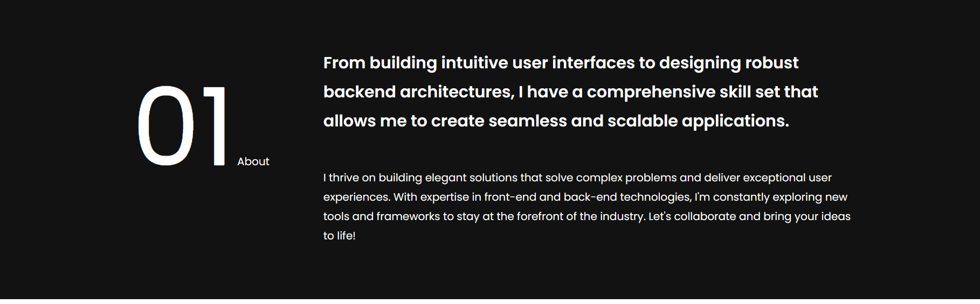

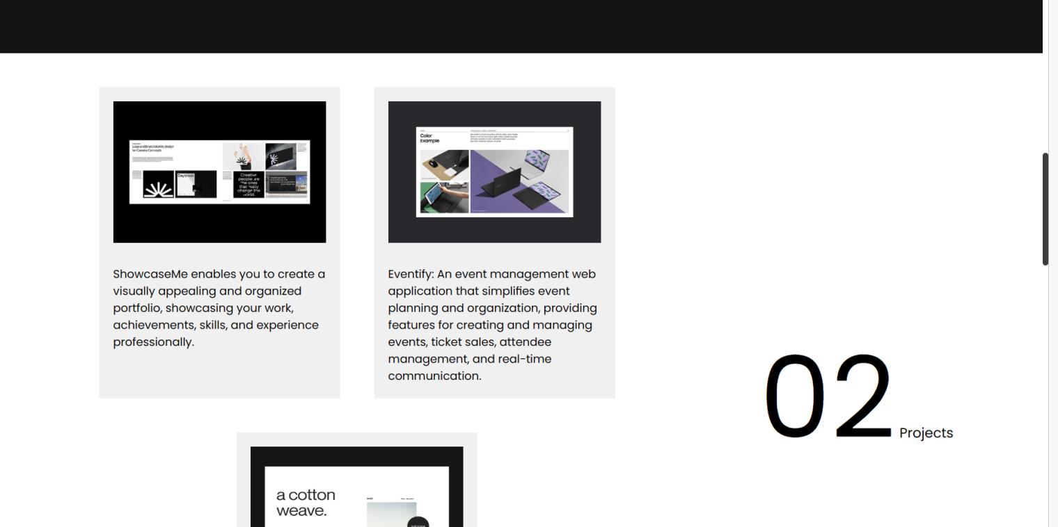

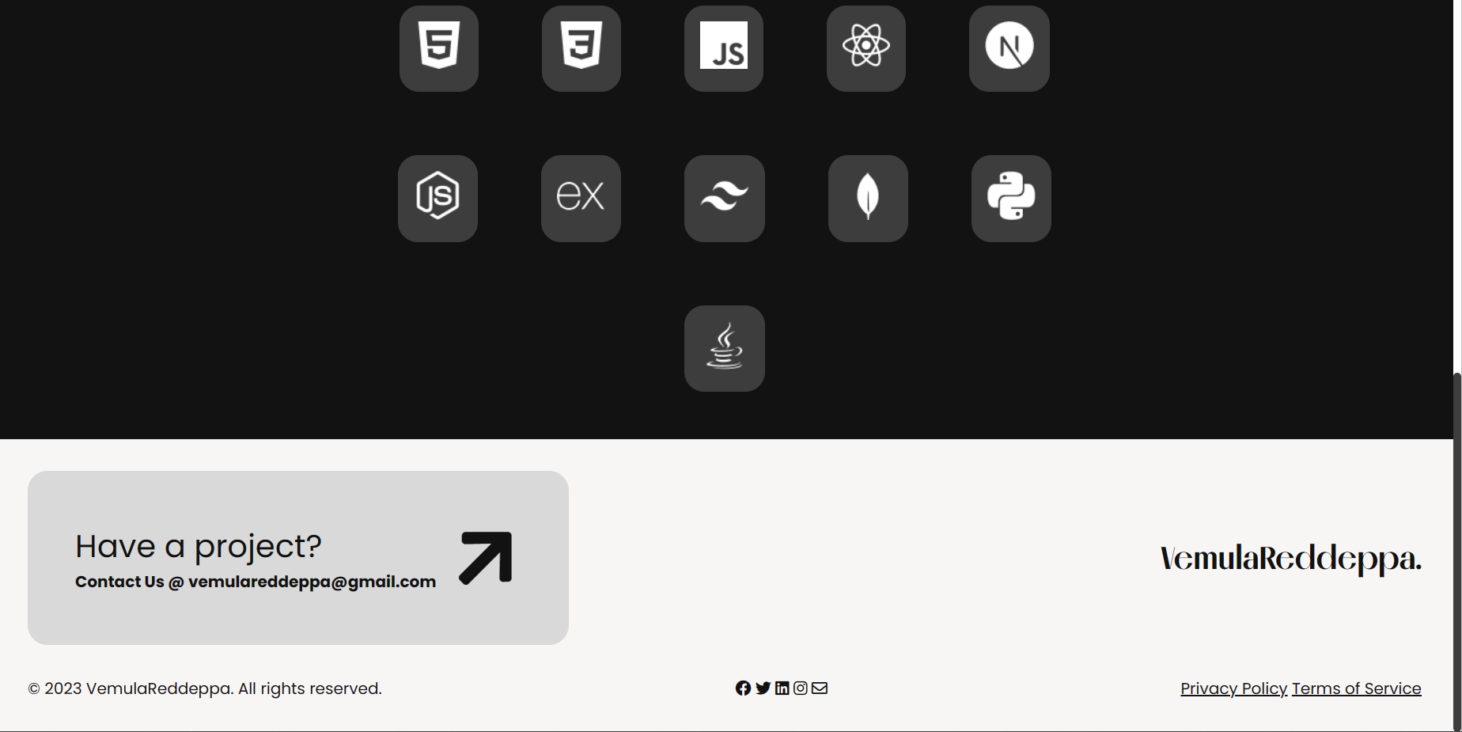

**ADVANTAGES AND DISADVANTAGES**

Here are some advantages and disadvantages of personal portfolio apps:

#### Advantages:

*  [A personal portfolio app can help you showcase your work and achievements](https://www.investopedia.com/articles/personal-finance/010616/pros-cons-using-roboadvisor.asp) [in one place 1.](https://www.investopedia.com/articles/personal-finance/010616/pros-cons-using-roboadvisor.asp)
* [It can help you stand out from other candidates when applying for jobs](https://www.investopedia.com/articles/personal-finance/010616/pros-cons-using-roboadvisor.asp) .
* [It can help you track your progress and set goals for the future .](https://www.investopedia.com/articles/personal-finance/010616/pros-cons-using-roboadvisor.asp)
* It can help you network with other professionals in your field.

#### Disadvantages:

* + A personal portfolio app can be time-consuming to create and maintain.
  + It may require technical skills to create a professional-looking app .
  + It may not be suitable for everyone, especially those who are not comfortable sharing their work online .

# APPLICATIONS

Personal portfolio apps can be used in various ways, such as:

* **Showcasing your work**: A personal portfolio app can help you showcase your work and achievements in one place.
* **Networking**: It can help you network with other professionals in your field.
* **Job applications**: It can help you stand out from other candidates when applying for jobs.
* **Tracking progress**: It can help you track your progress and set goals for the future.
* **Personal branding**: It can help you create a personal brand and establish yourself as an expert in your field.
* **Marketing**: It can be used for marketing purposes to promote your business or services.

## CONCLUSION

Personal portfolio apps can be used in various ways, such as showcasing your work, networking, job applications, tracking progress, personal branding, and marketing. A personal portfolio app can help you showcase your work and achievements in one place, which can help you stand out from other candidates when applying for jobs. It can also help you track your progress and set goals for the future. However, creating and maintaining a personal portfolio app can be time-consuming and may require technical skills to create a professional-looking app. It may not be suitable for everyone, especially those who are not comfortable sharing their work online . I hope that helps!

**FUTURE SCOPE:**

The future scope of personal portfolio apps is vast. [According to Investopedia, there are](https://www.investopedia.com/articles/investing/031115/5-top-portfolio-management-apps.asp) [several mobile apps that offer real-time information on all your investments in a one-stop](https://www.investopedia.com/articles/investing/031115/5-top-portfolio-management-apps.asp) [place .](https://www.investopedia.com/articles/investing/031115/5-top-portfolio-management-apps.asp) These apps can provide information on your investments from 401k (s) to IRAs. Some portfolio management apps can sync with your existing accounts, and most are free. [Some](https://www.investopedia.com/articles/investing/031115/5-top-portfolio-management-apps.asp) [of the most popular apps include Empower (formerly Personal Capital), SigFig Wealth](https://www.investopedia.com/articles/investing/031115/5-top-portfolio-management-apps.asp)

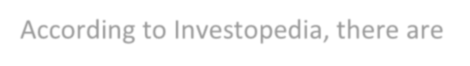

[Management, Sharesight, and Yahoo Finance .](https://www.investopedia.com/articles/investing/031115/5-top-portfolio-management-apps.asp)

[In addition, DevTeam.Space suggests that you can build an investment portfolio app](https://www.devteam.space/blog/how-to-build-an-investment-portfolio-app/) [thatoffers features like that of “Personal Capital”](https://www.devteam.space/blog/how-to-build-an-investment-portfolio-app/) . You can build a web, an Android, and an iOS app and support English-speaking users. You need to determine which features you willoffer in your “Minimum Viable Product” (MVP), subsequently, you can enhance the app based on market feedback

## 